Task 2 from AYESHA SAMEER BAGWAN

1. SQL Query Interface (Manual Text-Based)

### Why You Use It:

* Full control over data operations.
* Ideal for advanced users, automation, and scripting.
* Required when writing complex queries or batch operations.

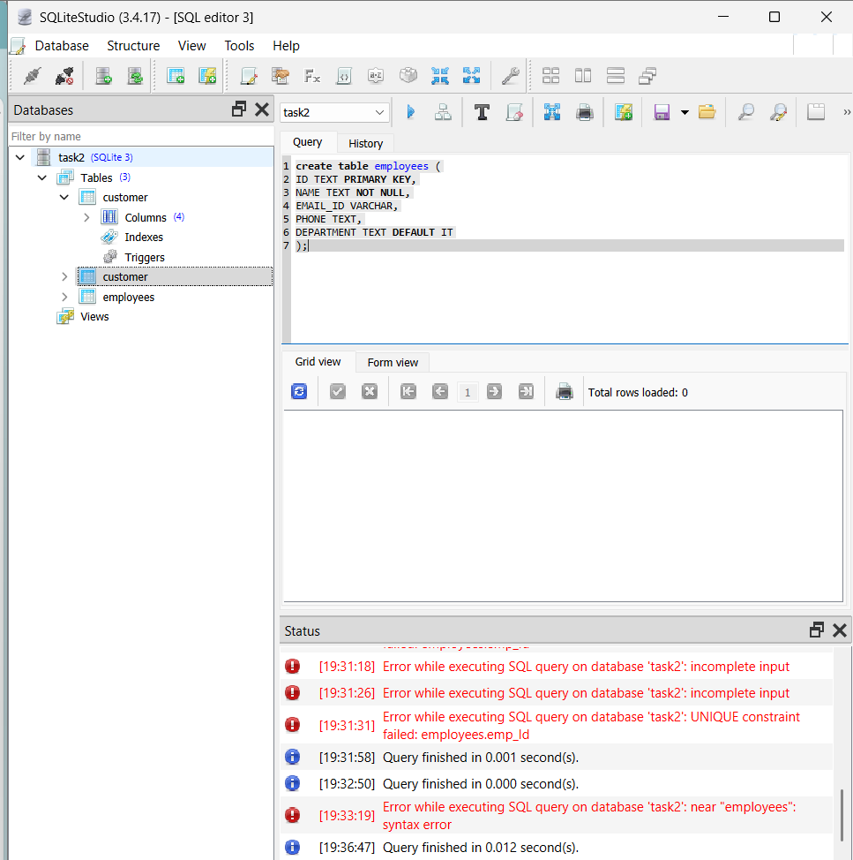

1. Use INSERT INTO FOR ADDING ROWS

2.Handle missing values using NULL or default

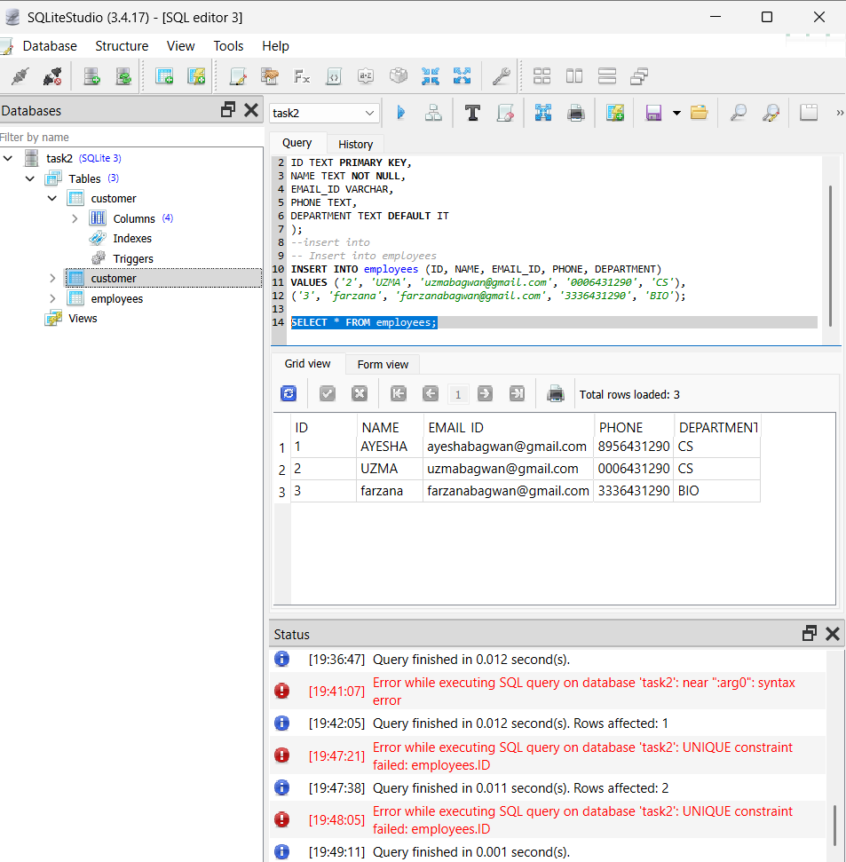

3.Use UPDATE and DELETE with WHERE conditions 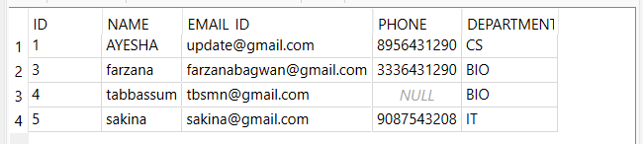

**🔹 2. GUI / Grid Interface (Visual Table View)**

**✅ What You Do:**

* Open the database file (.db) using a GUI tool.
* View, edit, add, or delete records in a spreadsheet-style interface (grid).
* No SQL commands required — point and click

